Chinnock, Simon

Bega District Diary By ANNETTE HAIGH Feb. 2, 2006
- 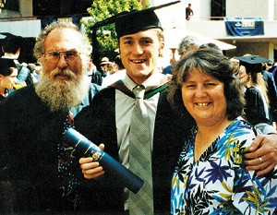
Simon Chinnock is joined by his proud parents, Greg and Wilma Chinnock of Quaama, on his graduation day.
BSc Forestry ANU 2005 (final year 2004).

